Al Imam Mohammad Ibn Saud Islamic University College of Computer and Information Sciences
Information Systems Department
Course Title: | App Development
Course Code: | IS337
Course Instructor: | Dr. Prabu Pachiyannan Dr Fareeha Anwar.
Exam: | Assignment
Semester: 2nd 2025-26
Due Date: 12/4/2025 Marks:
5
Privileges: ☐ Open Book ☐ Open Notes


☐ Calculator Permitted ☐ Laptop Permitted
 | Group Number: |  |  | Group 1 : Abdullah Sami AlAhmed (443014578)  Nasser AlRashed(443014711)
 | Section Number: |  |  | 174
Instructions:
- Answer all requirements; there are (8) requirements in (3) pages.
- Upload on the Blackboard a zip file of your assignment folder (report included).
- You are required to follow the rules of plagiarism (see last page)
 |  |  | Official Use Only
 |  | Question | Student Marks |  | Question Marks
 |  | 1 |  |  | 5
 |  | Total |  |  | 5
Page 1 of 3

PLO S2, S4:

Apply HTML5
, CSS3
and related technologies to create simple web sites

PLO

V1, V2
:

Function effectively on teams to accomplish a common goal.
Saudi Arabia Railways (SAR)
(Website)
The main aim of this coursework is to develop a web-based student wise site to share with all subscribed users valuable information to travel in different cities via train. It’s the first phase of an overall project for sharing information, using HTML5/CSS3 languages as the software instruments of choice.
Included features-requirements of this web site:
- Design your own steady design environment with logos (college/department) that will create the basic and steady “atmosphere” of your web site with a short (1 line)

A. Each web page contains:
  - Add a relevant background image fading behind as part of the steady environment and relevant to your web page mission. A background image(s), your logos
  - The needed (text and image) menus and design of your own that will create the basic and steady “atmosphere” of your web site
  - A short (1 line) copyright notice e.g. (© 2nd-2025-26 / IMSIU / CCIS TM) at each page footer bottom (center and bottom of the screen).
  - Provide contact details and social media hyperlinks in the header bar as part of the steady environment (email, telephone & 2 social media hyperlinks).
  - Include the feature of auto refreshing the page every 12 hours
Your basic menu should come after the contact details menu
- “Home” option and when clicked display a welcome message and some general information about the SAR; : الخطوط الحديدية السعودية), a menu “Travel with SAR”
  - when you click “Travel with SAR”, it will display all the cities where the train will go, their fares travel time and all related information. Also display maps.
Tip: There is going to be a lot of scrolling in this menu choice. (use internal linking)
- “Gallery” Display Pictures and videos
- “Create Account” option for user to register to this Web Site creating and displaying a form of the next inputs: name, ID, Date of Birth, Nationality, Mobile-Number and email address password. (apply all checks for inputs)
- “Sign in” option for students to access display a UI with name and password so to be able to see as an extra menu choice of the next requirement.
• When student sign in they can see “Book a ticket” button and can reserve tickets. (only registered users)
- “Book a ticket” when clicked give a useful page display with following options You can change the styles according to your webpage style but information should remain same.
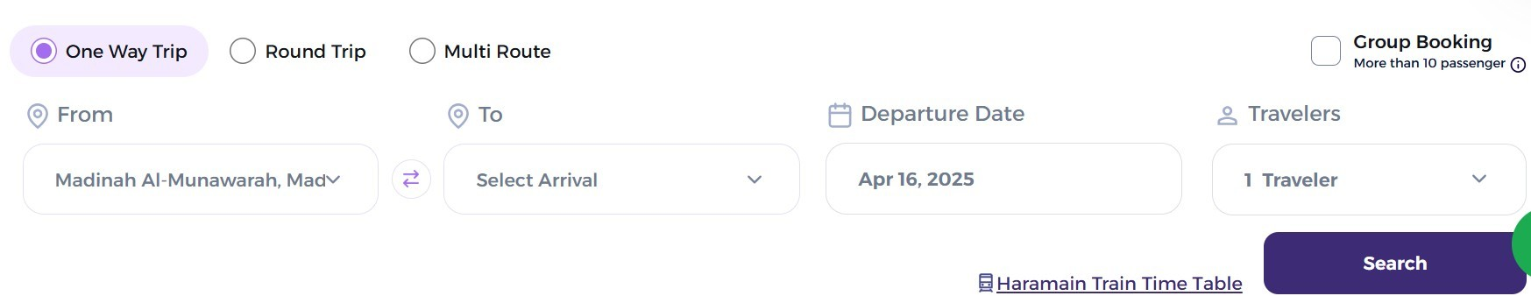
- The soft copy of your Assignment should be very well organized and saved under a project folder named after your section and group (e.g. 371_group1 or 171_group1 etc.) including the soft copy of your report too. (1 mark)

Tip : Start your development with the creation of an html main-master-index file to build your web site.


Note:

  - You must create drop-down menu(s).
  - You must use images
  - Special attention should be given for the design quality of the web pages
  - Presenting a sophisticated, professional and “user-friendly” web site
Special attention should be given to the design quality of this web page, using all possible means available to this course to present a well design sophisticated, professional and “user-friendly” web site.
This is a group project and the following rules apply:
- Students are expected to deliver the project on time to get full grade for the project. If delayed up to 1 week the project will get a 60% (pass). If delayed more than 1 week it will not be accepted.
- Groups of Students are expected to work separately. Plagiarism will not be tolerated. If two or more groups work together, all of them will get 0% (no matter who initiated plagiarism).
- Upload the assignment in a .zip file through the Blackboard system including all needed files for your project to work smoothly with the Browser of your choice (report in a word file, HTML files, css3 file or files, picture files etc.)
Page 3 of 3

